Present simple vs present continuous.
Time expressions
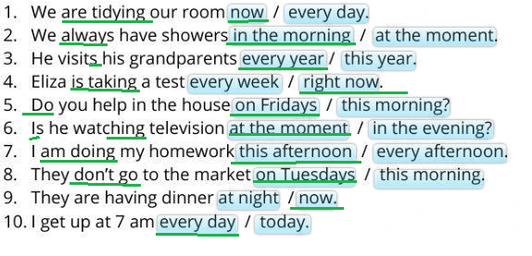

Verbal form
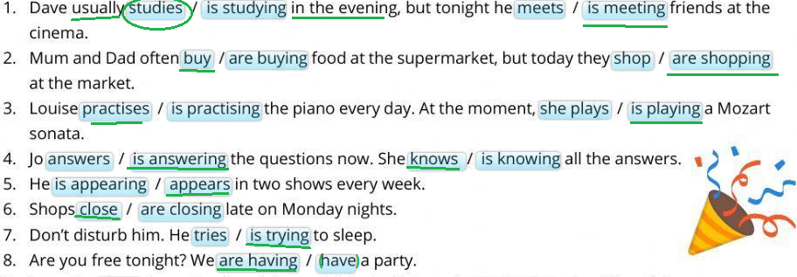

Complete the text
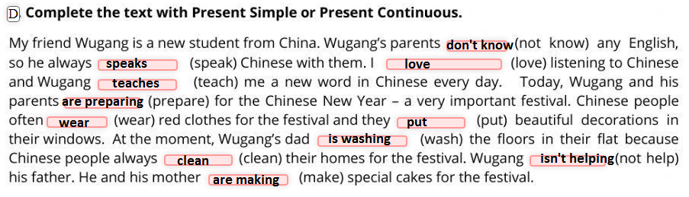

Retrived from:
https://www.liveworksheets.com/es/w/en/english-second-language-esl/1380240
https://test-english.com/grammar-points/a2/present-simple-continuous/3/

